

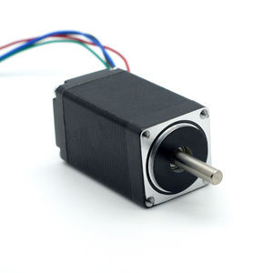

#### 28mm Hybrid Stepper Series

**SPECIFICATIONS:**

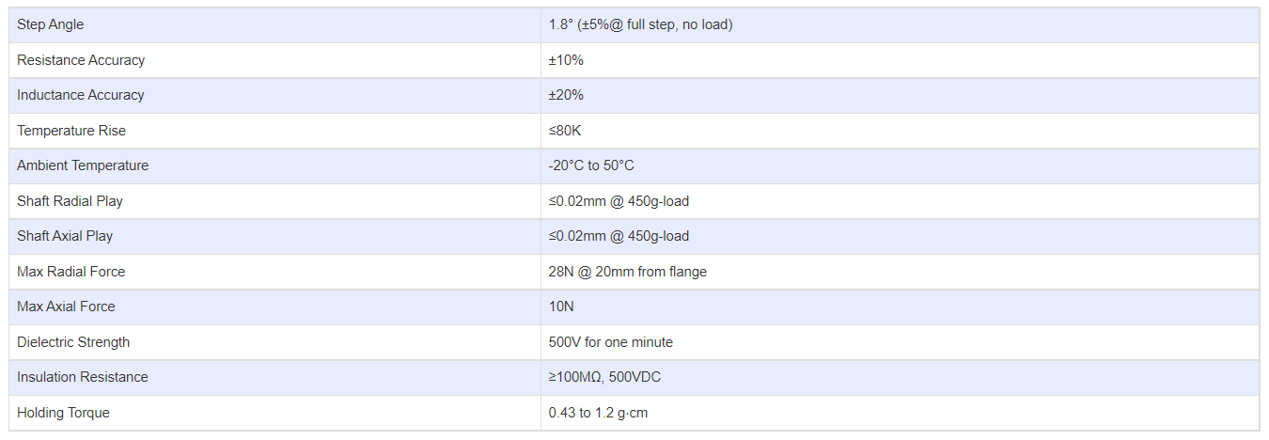

**SUBMODELS:**

*The following are common sub models for the LDO-28STH series.*

